**DAILY ONLINE ACTIVITIES SUMMARY**

|  |  |  |  |  |  |  |  |  |
| --- | --- | --- | --- | --- | --- | --- | --- | --- |
| **Date:** | **11/06/2020** | | | | | **Name:** | **Soundarya R** | |
| **Sem & Sec** | **6th & B** | | | | | **USN:** | **4al17cs096** | |
| **Online Test Summary** | | | | | | | | |
| **Subject** | |  | | | | | | |
| **Max. Marks** | |  | | **Score** | | |  | |
| **Certification Course Summary** | | | | | | | | |
| **Course** | **Cloud Computing with AWS** | | | | | | | |
| **Certificate Provider** | | | **Great Learning Academy** | | **Duration** | | | **12 hours** |
| **Coding Challenges** | | | | | | | | |
| **Problem Statement:2programs** | | | | | | | | |
| **Status:solved** | | | | | | | | |
| **Uploaded the report in Github** | | | | | **yes** | | | |
| **If yes Repository name** | | | | | **http://github.com/ashu102/Daily-Activities** | | | |
| **Uploaded the report in slack** | | | | | **yes** | | | |

Certification Course Details:

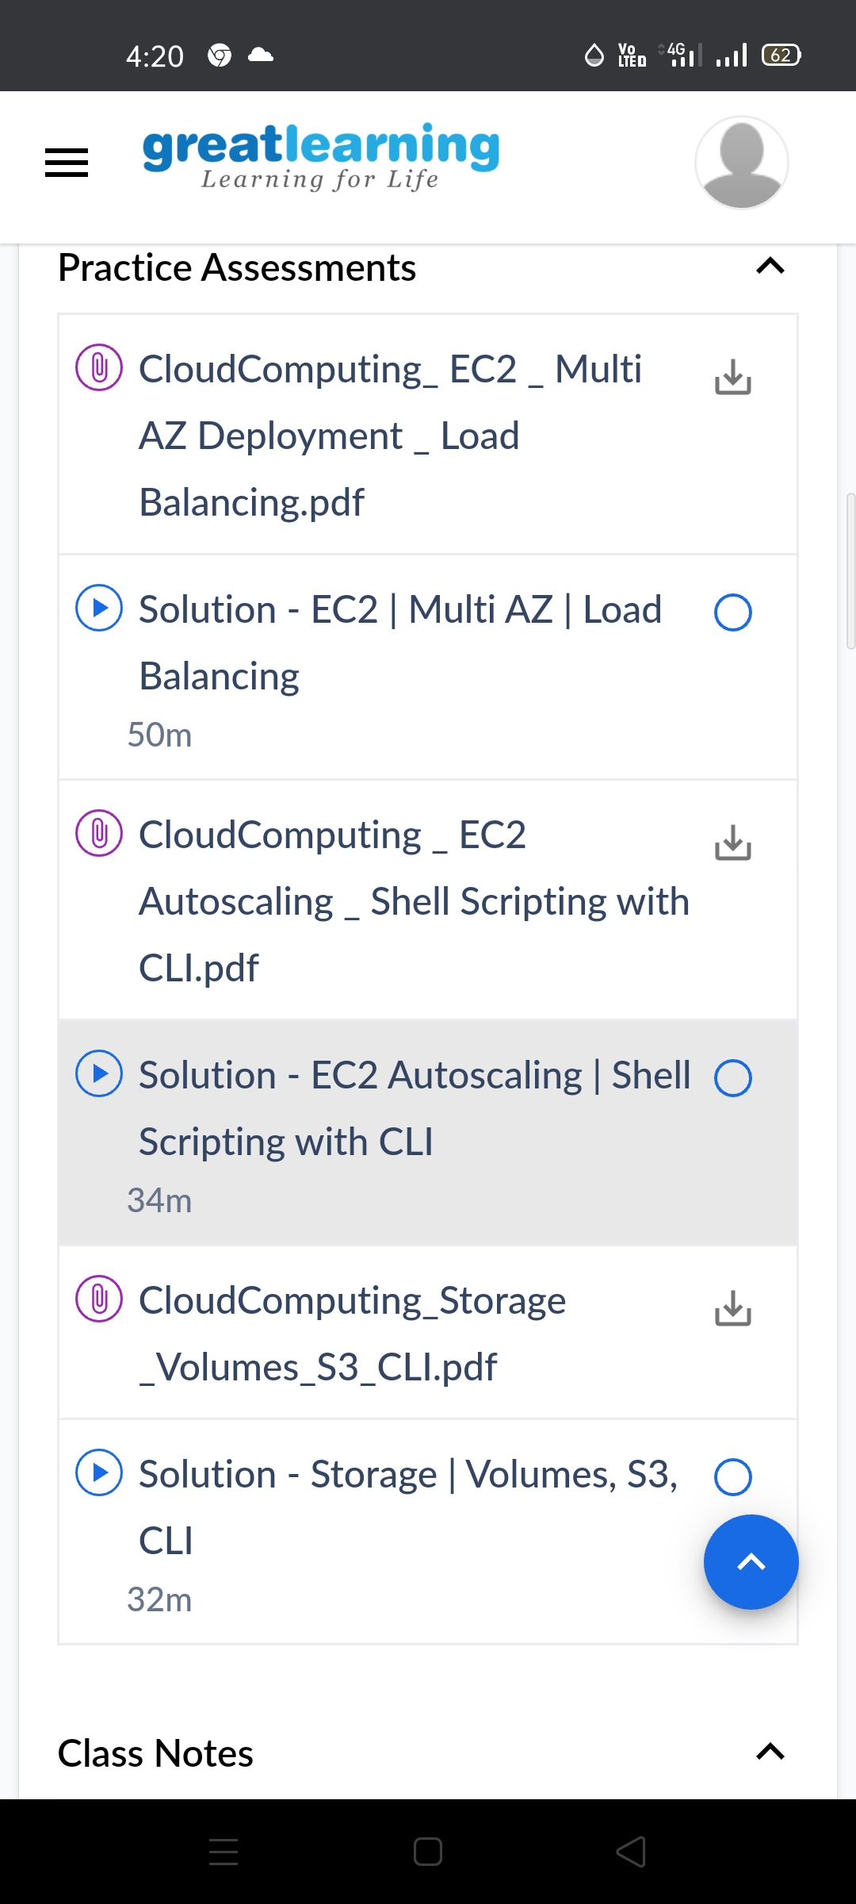

Coding Challenges Details:

1. Write a python function that converts a string to all uppercase, provided it contains at least 2 uppercase characters in the first 4 characters. Else print the string as it is

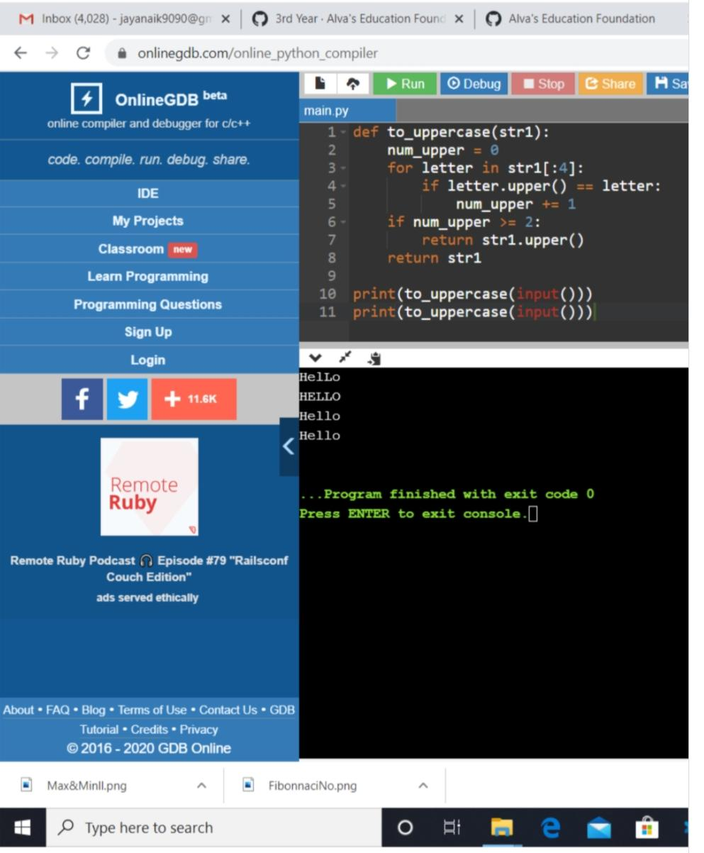

2. Python Program to find the average of all Items in a Dictionary Step1: Get the name as key and marks as value for n students Step2: find the average of the marks of all the students and print it

